# Press Release

**Contact**

Detlef Brands   
Schunk Ingenieurkeramik GmbH  
Hanns-Martin-Schleyer-Strasse 5 47877 Willich  
Germany

Tel +49 (0) 2154 497 113  
Fax +49 (0) 2154 497 111

ceramics@schunk-group.com  
schunk-carbontechnology.com

**New dimensions for 3D printing of technical ceramics**

**Schunk Carbon Technology at the Ceramitec 2018**

**Munich/Willich, April 10th, 2018 – In line with this year’s theme of “The new 3D,” Schunk Carbon Technology is raising additive manufacturing to a new level and is showcasing its competence at this year’s Ceramitec in Munich. With Schunk 3D printing, ceramic components are now available in even more complex shapes, higher quality, and in numerous sizes. Schunk will be presenting three highlights from its technical ceramics series at the trade show:**

* **IntrinSiC®, the 3D printing process of silicon carbide construction elements, with higher homogeneity and reliability**
* **EcoLight, the weight-optimized kiln furniture system**
* **IntrinSiC® helmet inlets for high performance protective helmets**

**You can experience these and other innovations live on April 10-13, 2018 in Hall A5, Booth 201/302.**

Extremely temperature-resistant, hard, and shatter-resistant: technical ceramics from Schunk are tried-and-tested materials with valuable properties for special requirements. Visitors to Ceramitec will be able to experience this for themselves. The components made of silicon carbide and aluminum oxide guarantee economic efficiency, energy efficiency, and reliable production processes. The specialists from Willich will bring numerous innovations to the trade show in Munich.

**IntrinSiC®: Silicon carbide 3D printing components**

Schunk ceramic components continue to deliver where other materials fail. Based on this claim, the company has succeeded in increasing the homogeneity of this extremely hard material, thus also significantly increasing the reliability and strength of the 3D printing components. Therefore, significantly more complex and larger structures can be produced compared to other methods. Ever since the world debut of IntrinSiC® at the last Ceramitec, the further development of the material has given rise to completely new fields of application. As a first mover in this sector, Schunk also offers its expert knowledge as a service: the company helps customers design components using FEA (finite element analysis) to optimize reliability, weight savings, and mechanical structural properties.

**IntrinSiC® technology for protective helmets: Safe thanks to high tech**

IntrinSiC® technology will also be used to develop new military protective helmets for the first time. Made of advanced silicon carbide, the inlets even withstand armor-piercing rounds. Customized shapes are possible thanks to the innovative process and the extraordinary characteristics of the advanced ceramic. The more homogeneous material and the associated increased strength ensure the optimal integration of the inserts into the helmet. The ceramic inlet will be on display at the trade show.

**EcoLight systems: weight-optimized and efficient**

EcoLight systems are the innovative, weight-optimized kiln furniture systems from Schunk Carbon Technology. Individual constructive design solutions with a focus on energy efficiency, operational safety, and product life are designed according to the respective requirement profile. High energy efficiency during the firing process significantly reduces process costs. For example, Eco-Light® Beams made of silicon carbide offer up to 40 percent greater flexural strength than conventional variants. In combination with the 3D technology, IntrinSiC® offers a great deal of creative design freedom. CarSIK-NG-based perforated batts, known as Bore-Grids, ensure weight savings of more than 50 percent compared to cordierite. They are particularly suitable for firing sanitary ceramics and achieve a significant increase in efficiency through convective flows as well as a more homogeneous temperature distribution. Customers also report a significantly reduced reject rate of fired goods.

**Additive manufacturing exhibition tour: experience innovation live**

Additive manufacturing is one of the main topics at this year’s Ceramitec. Therefore, the organizers are offering guided tours for interested visitors. This will allow guests to experience the innovations of the relevant players, including Schunk Carbon Technology, live at the event.

Ceramitec will take place from April 10-13, 2018 at the Neue Messe München (exhibition center in Munich). Schunk is presenting in hall A5 at booth 201/302.

(4,322 characters incl. spaces)

**Schunk Ingenieurkeramik GmbH is a company of Schunk Carbon Technology**

Schunk Carbon Technology, the largest division of the international Schunk Group, is the world leader in the development and production of materials and components in mechanical carbon, electrical carbon, thermal carbon, and technical ceramics. With its highly specialized product portfolio and its core competencies in materials and their application-specific design, shape, and surface treatment, this division is a pioneering development partner in a wide range of industries, including the automotive industry, railway technology, aviation, the process industry, plant and machinery construction, the energy sector, as well as the ceramics, heat treatment, and semiconductor industries.

**Schunk Group**

The Schunk Group is an international technology group with over 8,000 employees in 29 countries. The company offers a wide range of products and services in carbon technology and ceramics, environmental simulation and air conditioning technology, sintered metal, and ultrasonic welding. The Schunk Group achieved sales of 1.1 billion euros in 2016.

**Images**Reprint free of charge. Please credit Schunk Carbon Technology as source.

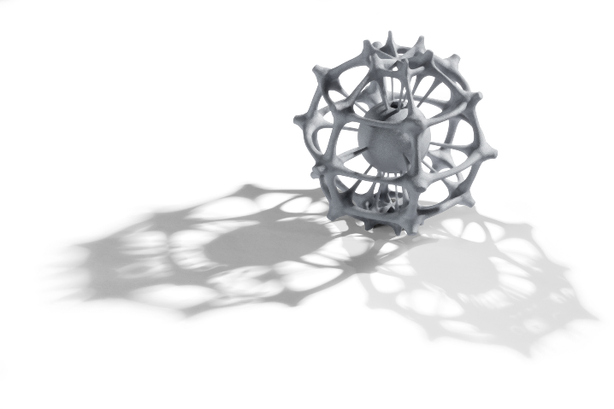

**IntrinSiC®** - 3D ceramics printing process for thermally stable lightweight components (bionic structure, Prof. Gerhard Hahn and Kerstin Froch, Hochschule Niederrhein, University of Applied Sciences)

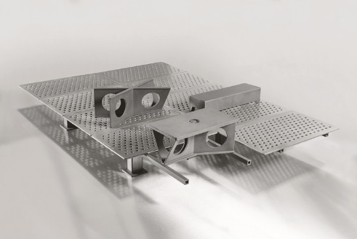

*Sanitary* EcoLight System

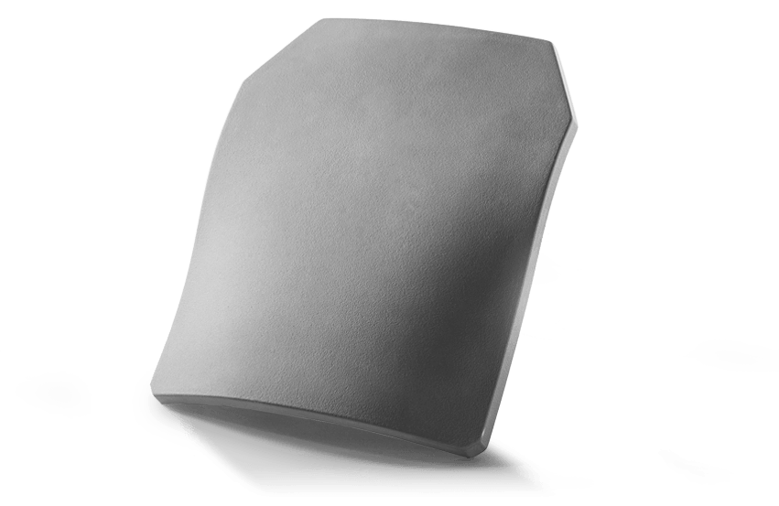

Monolithic plates for protective vests